**Industrial Internship Report on**

**”Password Manager using Python”**

**Prepared by**

**Potturu Sai Harika**

|  |
| --- |
| *Executive Summary* |
| This report provides details of the Industrial Internship provided by upskill Campus and The IoT Academy in collaboration with Industrial Partner UniConverge Technologies Pvt Ltd (UCT).  This internship was focused on a project/problem statement provided by UCT. We had to finish the project including the report in 6 weeks’ time.  My project was Password Manager using Python which manages password ,generates password and stores in database to retrive when required. To develop this we used python Tkinter module and sql databse etc.,  This internship gave me a very good opportunity to get exposure to Industrial problems and design/implement solution for that. It was an overall great experience to have this internship. |

**TABLE OF CONTENTS**

1 Preface 3

2 Introduction 4

2.1 About UniConverge Technologies Pvt Ltd 4

2.2 About upskill Campus 8

2.3 Objective 9

2.4 Reference 9

3 Problem Statement 11

4 Existing and Proposed solution 12

5 Performance Test 14

5.1 Test Plan/ Test Cases 14

5.2 Test Procedure 14

5.3 Performance Outcome 15

6 My learnings 16

7 Future work scope 17

# Preface

Password Manager is an GUI based application that allows users to store and generate random passwords. It is created in Python using Tkinter and Mysql database to manage passwords for several application. A password manager is a program that houses all your passwords, as well as other information, in one convenient location with one master password . The benefits of using Password Manager are:

* A Password Manager will do the work of creating the complicated passwords you need to help protect your online accounts.
* You need to remember only the password manager’s password. That single password will give you access to all of your others.

Not only do password managers help securely house your passwords, but they can also generate passwords that are unique and complex, which makes them more difficult to crack or guess. It also simplifies your life by making account access easier for you and more difficult for hackers. You don’t have to memorize any passwords except for the password to your password manager . That means you can actually follow unpleasant but useful security advice, likenever reusing a password and always using long, strong and complex passwords.

**Objectives and scope:**

In this project, we build an application which will store the User’s password , as well as other information, in one convenient location with one master password .Python Features and methods are used to implement in this project. Today, people have a large number of passwords for social media sites , work logins, shopping pages, online banking and much more. While it is important to use strong passwords and to use different passwords on each site , it can be a difficult task to remember all them. With a password manager, you simply enter the GUI app, provide the master password you set for the password manager in that software, then log in to the GUI app and the username and password will be stored for you. However, the primary purpose of this project to make Password Manager application user-friendly so that any individual can interact with the system . The main scope and deliverables of the project would be to:

* Understand and prepare detailed user requirement and specifications.
* Prepare high level and detailed design specifications of the system.
* Prepare Test Plan & Test cases.
* Develop the system and coding.
* Perform unit testing, integration testing and system testing.
* Demonstrate a bug free application after suitable modification, if needed.
* Develop a GUI application using Python Tkinter.

This project helps us to enhance my knowledge by developing an application which stores passwords and helps user ambiguity and confusion about passwords to be remembered.This internship provided by UCT helps me to improve weightage of my resume and upgrade my knowledge in Python which further helps me to achieve my goals.

This is an 6 weeks internship program.

In first week of internship we the group of 5 planned to work on one of the problem given by UCT.

Later on we took help from one of my lecturer from college Mr.Shayeez ahmed sir to plan for overall project. We gone through the many online resources,available resources in our college to get know initial ideology to develop an solution.

In later on 5 weeks we tried to develop as mentioned in weekly reports, we had tested with various sample cases and gone through failure but we overcame with the help of our senior.

Overall of 6 weeks,we learned how to develop an solution to problem as a no experience initially. We Had learned how to utilize resources . also learned to manage team work and develop my built-in skills in python to next step of improvement.And I had experienced a working as a team to complete an problem.

Thanks to **Mr.Shayeez ahamed** sir for helping us to complete this project with ur support. And thanks to my co-team members Sai Lavanya.K , Poojitha.V , Rizwana.D, Revathi.M who worked along side to complete project without fail.

Thanks to IOT academy,UCT and unicoverage technologies , upskill campus for providing us the opportunity.

1. **Introduction**

## About UniConverge Technologies Pvt Ltd

A company established in 2013 and working in Digital Transformation domain and providing Industrial solutions with prime focus on sustainability and RoI.

For developing its products and solutions it is leveraging various**Cutting Edge Technologies e.g. Internet of Things (IoT), Cyber Security, Cloud computing (AWS, Azure), Machine Learning, Communication Technologies (4G/5G/LoRaWAN), Java Full Stack, Python, Front end**etc.

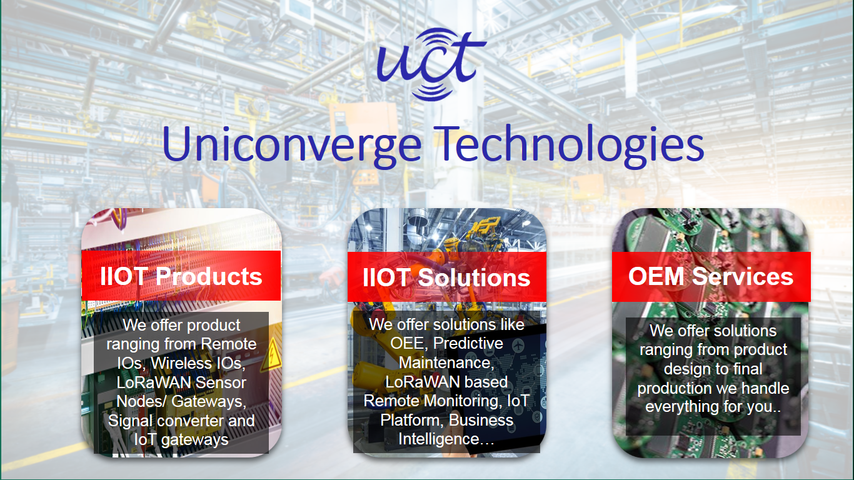

1. UCT IoT Platform **(****)**

**UCT Insight** is an IOT platform designed for quick deployment of IOT applications on the same time providing valuable “insight” for your process/business. It has been built in Java for backend and ReactJS for Front end. It has support for MySQL and various NoSql Databases.

* It enables device connectivity via industry standard IoT protocols - MQTT, CoAP, HTTP, Modbus TCP, OPC UA
* It supports both cloud and on-premises deployments.

It has features to  
• Build Your own dashboard  
• Analytics and Reporting  
• Alert and Notification  
• Integration with third party application(Power BI, SAP, ERP)  
• Rule Engine

 

1. **Smart Factory Platform (****)**

Factory watch is a platform for smart factory needs.

It provides Users/ Factory

* with a scalable solution for their Production and asset monitoring
* OEE and predictive maintenance solution scaling up to digital twin for your assets.
* to unleased the true potential of the data that their machines are generating and helps to identify the KPIs and also improve them.
* A modular architecture that allows users to choose the service that they what to start and then can scale to more complex solutions as per their demands.

Its unique SaaS model helps users to save time, cost and money.

 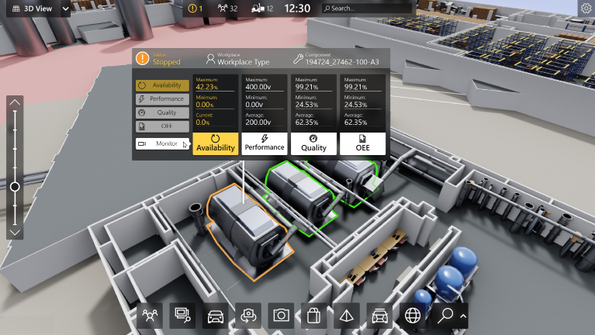

1. 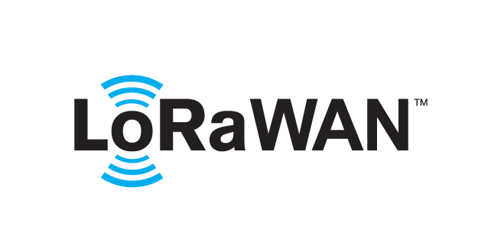 based Solution

UCT is one of the early adopters of LoRAWAN teschnology and providing solution in Agritech, Smart cities, Industrial Monitoring, Smart Street Light, Smart Water/ Gas/ Electricity metering solutions etc.

1. Predictive Maintenance

UCT is providing Industrial Machine health monitoring and Predictive maintenance solution leveraging Embedded system, Industrial IoT and Machine Learning Technologies by finding Remaining useful life time of various Machines used in production process.



## About upskill Campus (USC)

upskill Campus along with The IoT Academy and in association with Uniconverge technologies has facilitated the smooth execution of the complete internship process.

USC is a career development platform that delivers **personalized executive coaching** in a more affordable, scalable and measurable way.



Seeing need of upskilling in self paced manner along-with additional support services e.g. Internship, projects, interaction with Industry experts, Career growth Services

<https://www.upskillcampus.com/>

upSkill Campus aiming to upskill 1 million learners in next 5 year

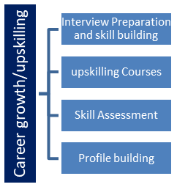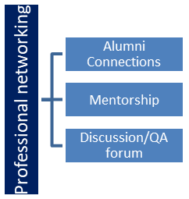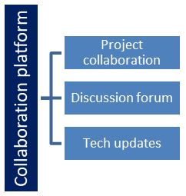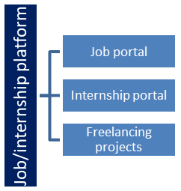

## The IoT Academy

The IoT academy is EdTech Division of UCT that is running long executive certification programs in collaboration with EICT Academy, IITK, IITR and IITG in multiple domains.

## Objectives of this Internship program

The objective for this internship program was to

 ☛ get practical experience of working in the industry.

 ☛ to solve real world problems.

 ☛ to have improved job prospects.

 ☛ to have Improved understanding of our field and its applications.

 ☛ to have Personal growth like better communication and problem solving.

## Reference

[1] <https://www.python.org/doc/>

[2] <https://www.youtube.com/watch?v=O8596GPSJV4>

[3] <https://stackoverflow.com>

**Problem Statement**

In the assigned problem statement

The password manager is a Python project that securely stores and manages user passwords. It allows users to store their passwords for various accounts, generate strong passwords, and retrieve passwords when needed.

# Existing and Proposed solution

Many companies proposed an solution to the password management but fails in case of password synchronization , encryption and management cost.

We tried to develop an solution with minimum management cost which can be used by anyone . and also tried to develop of better synchronized &encryption .

We hope development will be successful.

## Code submission (Github link)

<https://github.com/PotturuSaiHarika/PasswordManager_PotturuSaiHarika_USC_UGT.git>

## Report submission (Github link)

<https://github.com/PotturuSaiHarika/PasswordManager_PotturuSaiHarika_USC_UGT/blob/main/final%20report.docx>

**Data flow diagram:**

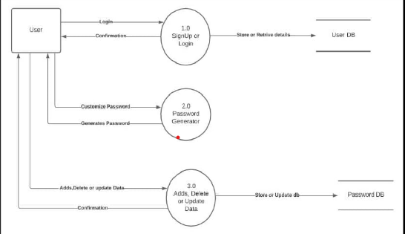

**Screenshots:**

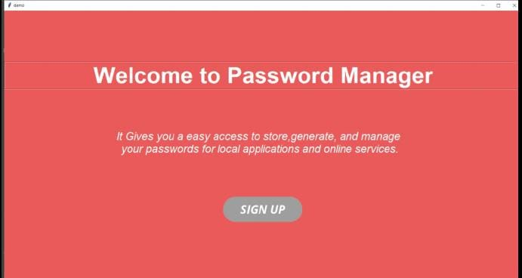

**Fig: welcome page**

**Login page:**

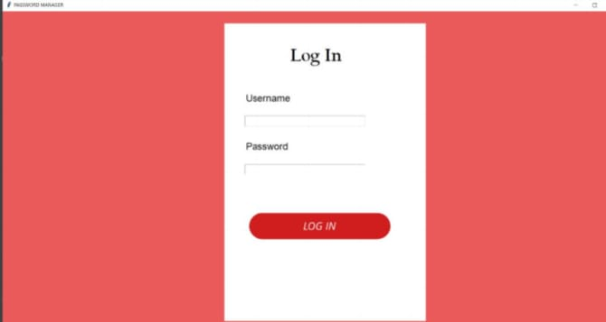

**Password manager:**

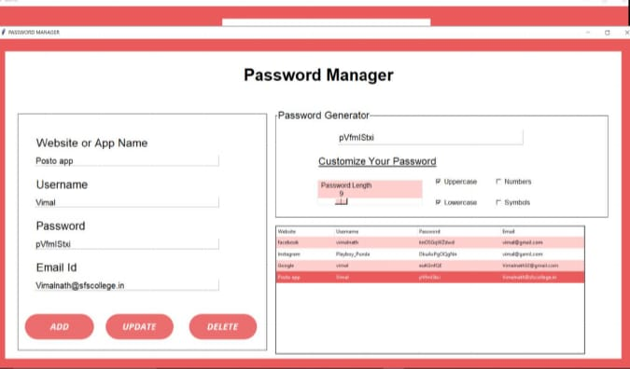

# Performance Test

Verification &validation Testing:

The purpose of requirement phase to verify all behavioral characteristics and performance requirements. Validation is achieved through a series of testing thar demonstrate conformity with requirements. Both the plan and the procedures are designed to ensure that all functional requirements are satisfied in the program.

* All behavioral characteristics are achieved.
* All performance requirements are attained.

**Black box testing:**

Black box testing is an approach to testing where the tests are derived from program or component specification. The system is a “black box” whose behavior can only be determined by studying its inputs and related outputs. The following methods are commonly used:

* Equivalence partitioning
* Boundary-value analysis
* Error guessing

**Features to be tested:**

* Verify that entries are of correct format
* No duplicate entries should be allowed
* All links should take the user to the correct page

**White box testing:**

White box testing is conducted to ensure that internal operations are performed according to specification and all internal components are adequately exercised. It is done to predict on close examination of procedural detail. White box testing is done:

* Guarantee that all independent paths within a module have been exercises at least once.
* Exercise all logical decisions on their true or false ideas.
* Execute all loops at their boundaries and within their operational bounds.
* Exercise internal data structure to assure their validity.

Testing was done for grouping row and column pixels.

**Unit testing:**

Unit testing focuses on the verification effort of the smallest unit of design module. Attention is diverted to individual modules, independently to locate errors.

This has enabled the detection errors in coding and logic. The various modules of the system are tested in unit testing method. The relative complexity of tests and the error detected as a result is limited by the constrained scope established for unit testing.

**Integration testing:**

The program as a whole is integrated into a single component and checked with test data. This is to check that the whole program works together correctly. The various modules are integrated first. Then the system is tested as a whole. Any misbehavior lead to dangerous problems and errors in the system.

The following points must be considered to clear potential interfacing problems in the process of designing the software.

1. Design error handling paths that test all information coming from other elements of the system.
2. Conduct a series of tests that simulate bad data or other potential errors at the software interface.
3. Record the results of tests to use evidence if finger pointing occurs.
4. Participate in the planning and design of system tests to ensure that software is adequately tested.

**Acceptance testing:**

User acceptance testing is a critical phase of any project and requires significant participation by the end user. It also ensures that the system meets the functional requirements.

**Test Result:**

All the best cases mentioned passed successfully. No defects encountered.

**5.My learnings:**

As a fresher, this project helped me to learn new things in depth of python. I had entered to a further step of improving my problem solving skills, team work and recovering from new challenges. I had learned the way of communicating in a software environment which made me experience the work environment and also made me to manage time for both academics & apart from academics. This will really help me to get into any role without any hesitations and can able to finish my role as expected.

# 6.Future work scope

This project is designed for the users who surf through internet a lot and create a number of online accounts and can’t keep track or memorize all of their online accounts login details. As the user’s requirement is always going to be changed which is not static. Project can be updated as per the user requirement and it is very flexible in terms expansion. The enhancement of the project can easily be made without changing the programming structure

The following are future enhancement of the project

* Enhancement of UI of application
* Converting the desktop application into web application

+